Addressing Access to Lethal Means

Most efforts to prevent suicide focus on why people take their lives. But as we understand more about who attempts suicide and when and where and why, it becomes increasingly clear that how a person attempts – the means they use –plays a key role in whether they live or die. (MeansMatter.org)

Take-home points
- Means safety for suicide prevention includes a range of strategies to reduce or eliminate access to lethal means for individuals at immediate risk of suicide.
- Reducing access to lethal means is one of the most effective, evidence-based strategies for preventing suicide.
- Most crises are short-term, therefore putting time and space between someone and lethal means can reduce risk of suicide.
- Most individuals who become suicidal have a specific means in mind, and do not substitute another means if the preferred method is unavailable. When substitution does occur, in most cases the substituted method is less lethal.
- Counseling on access to lethal means by health care providers and others is an effective suicide prevention strategy when providers are trained to have the conversation and in

“While reducing access to lethal means is a central element in global and national suicide prevention plans, it remains poorly understood – and underutilized for reducing suicide in California. Suicidal behavior is often method-specific, and a person’s choice of means is driven by multiple factors. These include the lethality, accessibility, and acceptability of the method. Eliminating or reducing access to a particular method during a crisis creates lifesaving time and opportunity for intervention. These dynamics are critical because crises involving suicidal behavior tend to be transient, and characterized by extreme ambivalence about the wish to die or stay alive. Research shows that when a person’s attempt is thwarted, he or she does not go on to die by suicide at other locations, times, or by other methods. As such, the placement of time between thoughts of suicide and a person’s ability to obtain lethal means for an attempt represents a practical, lifesaving approach to prevent suicide.”
(“Striving for Zero”, California’s Strategic Plan for Suicide Prevention 2020-2025)

Means Safety

Means safety refers to actions to reduce or eliminate access to lethal means for individuals that are experiencing thoughts of suicide. It includes efforts to reduce access to specific objects (e.g., medications, firearms, sharp objects) as well as locations (e.g. bridges, parking structures) that could be used in suicide attempts.
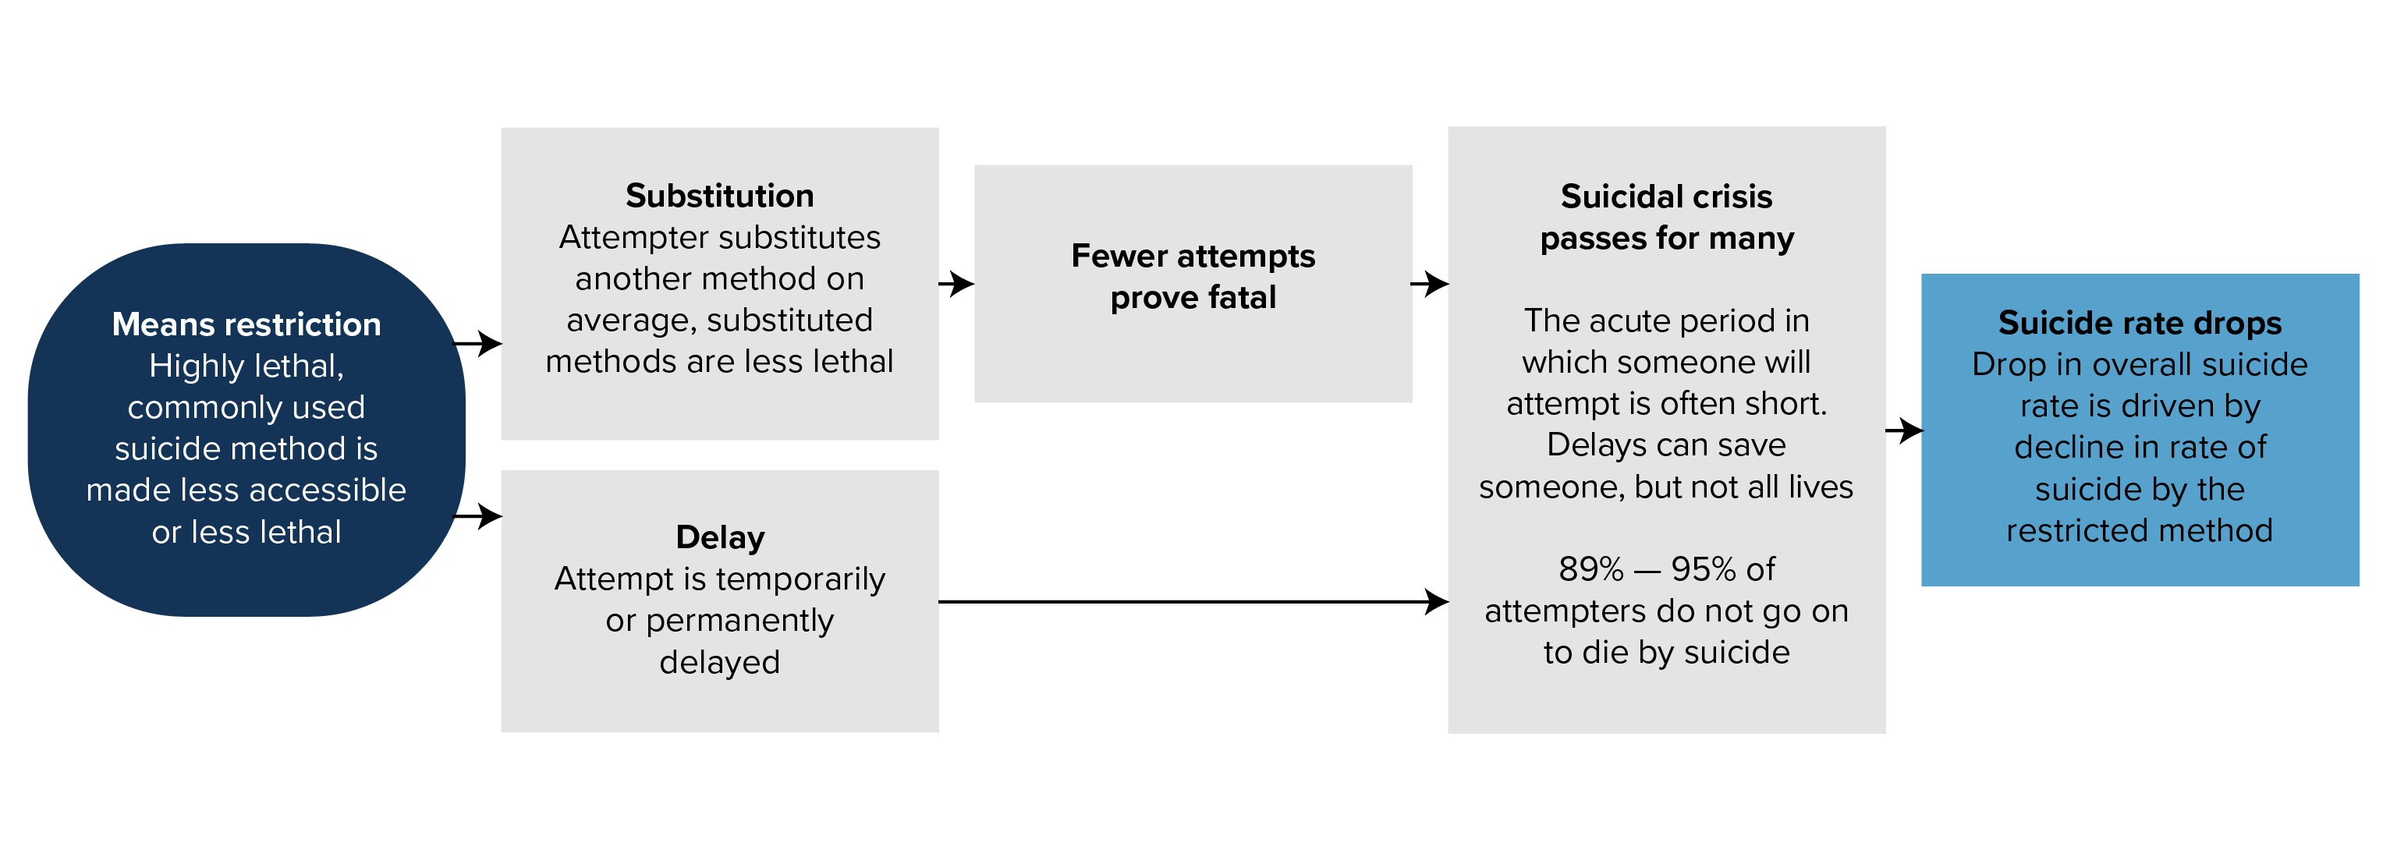
Source: Barber & Miller

There are a few key principles that are helpful to understand in supporting means safety approaches that are based on research and help to dispel some common misconceptions
.
- Most crises are short-term, therefore putting time and space between someone and lethal means can reduce risk of suicide and substitution.

- The means that someone chooses for a suicide attempt is not necessarily related to their level of intent to die. Interviews with suicide attempt survivors showed no distinction in intent to die based upon the means used.

- People often assume that if one means is taken away, that the person will simply use another method. However, research suggests that most individuals have a preference for a particular means and are unlikely to substitute if one is removed. If substitution of means does occur, the substituted method is likely to be less lethal.

- Since 70% of attempt survivors will not attempt suicide again in their lifetime and 90% of people who attempt suicide will not go on to die by suicide, if access to the most highly lethal means is restricted during a first attempt, that individual is unlikely to die by suicide.

Means safety is most effectively implemented as part of a comprehensive strategy that includes prevention and early intervention: identifying and helping people at risk, as soon as possible. Means safety is an “edge of the cliff” strategy - essential and effective, but the overarching hope is to prevent people from going further along the crisis pathway.

Citations
- Daigle MS. (2005). Suicide prevention through means restriction: Assessing the risk of substitution. A critical review and synthesis. Accident Analysis and Prevention

- Crosby, A.E., Han, B., Ortega, L.A., Parks, S.E., & Gfroerer, J. (2011). Suicidal thoughts and behaviors among adults aged ≥ 18 years – United States, 2008-2009. MMWR Surveill Summ. 2011 Oct 21;60(13):1-22. https://www.ncbi.nlm.nih.gov/pubmed/22012169

- Owens D, Horrocks J, and House A. Fatal and non-fatal repetition of self-harm: systematic review. British Journal of Psychiatry. 2002;181:193-199.

- Brown GK, Henriques GR, Sosdjan D, and Beck AT. Suicide intent and accurate expectations of lethality: predictors of medical lethality of suicide attempts. Journal of Consulting and Clinical Psychology. 2004;72(6):1170-74.

- Spicer, R. S., & Miller, T. R. (2000). Suicide acts in 8 states: Incidence and case fatality rates by demographics and method. American Journal of Public Health, 90, 1885-1891.

- Barber, CW & MJ Miller. Reducing a suicidal person's access to lethal means of suicide: a research agenda. Am J Prev Med. 2014 Sep;47(3 Suppl 2):S264-72. doi: 10.1016/j.amepre.2014.05.028. https://www.ncbi.nlm.nih.gov/pubmed/25145749

California Data

CALIFORNIA, Suicide by Method, 2013-2017 (ALL AGES)

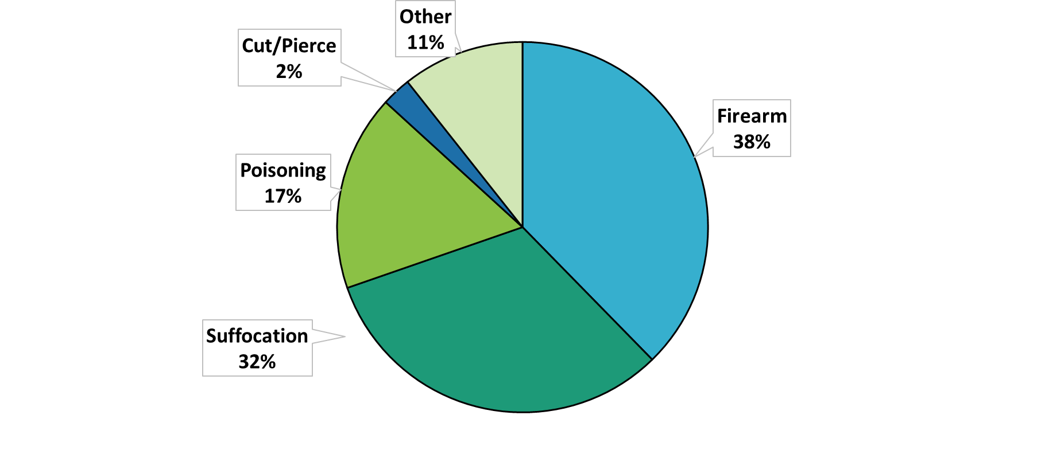 Source: CDC WONDER database
In California, firearms account for the majority of suicide deaths, followed by suffocation and poisoning. There are differences across the life span and between demographic groups in what means are most frequently used in deaths and in attempts. California is a large and diverse state, so local data may look different from the statewide picture even if the overall trends are similar. Below are resources to obtain data at the state and county level.

Mortality (fatal injuries) and morbidity data (non-fatal, intentional self-injuries) is externally valid and generally comes from Coroners, hospitals and Emergency room databases. Local data is aggregated and published at the state level but typically appears 2-3 years later, meaning in 2019 typically the most recent year of data would be 2016 or 2017. More timely data can be requested locally from the Coroner, hospitals and emergency departments.

State and county can be retrieved from the following:
- CA Department of Public Health EpiCenter; queries can be conducted by state, county, month, year(s) and several demographic variables
- County Health Status Profiles (annual)
- Centers for Disease Control and Prevention WISQARS database; queries can be conducted by state, county, year(s) and several demographic variables; WISQARS also compiles cost of injury and leading cause of death reports.

Data on the Effectiveness of Means Safety Approaches

Reducing access to lethal means is the most evidence-based suicide prevention strategy. Numerous studies have shown that when lethal means are made less available or less deadly, suicide rates by that method decline, and frequently suicide rates overall decline. The most effective strategies for lethal means restriction are physical deterrents.

Examples:
- United Kingdom: reduction of suicide following replacement of coal gas with natural gas (Kreitman)
- Israel: 40% reduction in suicides of soldiers when policies changed to require weapons to be stored on base. (Lubin et. al.)
- Sri Lanka: Ban on certain chemicals used in pesticides associated with reduction in suicides (Gunnell et. al.)
- New Zealand: Suicide deaths reduced to zero after barriers were reinstalled on bridges (Beautrais, Reisch & Michel).
- Multiple Countries: Limiting prescription size and altering packaging resulted in fewer suicides

Citations:
- Kreitman, N. The coal gas story: United Kingdom suicide rates, 1960-71. Br J Prev Soc Med. 1976 Jun; 30(2):86-93. https://www.ncbi.nlm.nih.gov/pubmed/953381

- Lubin, G., N. Werbelogg, D. Halperin, M. Shmushkevitch, M. Weiser, and HY Knobler. Decrease in suicide rates after a change of policy reducing access to firearms in adolescents: a naturalistic epidemiological study. Suicide Life Threat Behav. 2010 Oct;40(5):421-4. doi: 10.1521/suli.2010.40.5.421. https://www.ncbi.nlm.nih.gov/pubmed/21034205

- Gunnell D, Fernando R, Hewagama M, Priyangika WD, Konradsen F, Eddleston M. The impact of pesticide regulations on suicide in Sri Lanka. Int J Epidemiol. 2007;36(6):1235–1242. https://www.ncbi.nlm.nih.gov/pmc/articles/PMC3154644/

- Beautrais, A.L., Effectiveness of barriers at suicide jumping sites: a case study. Aust N Z J Psychiatry. 2001 Oct;35(5):557-62. https://www.ncbi.nlm.nih.gov/pubmed/11551268.

- Pelletier AR. Preventing suicide by jumping: the effect of a bridge safety fence. Inj Prev. 2007;13(1):57–59. doi:10.1136/ip.2006.013748. https://www.ncbi.nlm.nih.gov/pmc/articles/PMC2610560/#__ffn_sectitle

- Reisch, T. and K. Michel. Securing a Suicide Hot Spot: Effects of a Safety Net at the Bern Muenster Terrace. Suicide Life Threat Behav. 2005 Aug;35(4):460-7. https://www.ncbi.nlm.nih.gov/pubmed/16178698

Strategies to Promote Means Safety

There are four basic ways to restrict or reduce access to lethal means by persons at imminent risk of suicide:
- Place the person in a safer environment
- Put a barrier between the person and the means
- Create time between the person and the means
- Make the means (and an attempt) less lethal

There are some common elements among any means safety efforts: a public awareness component, where information and resources are available that help people understand the importance of means safety and how they can use the information; trainings for key gatekeepers that offer specific information about their role in promoting and supporting means safety; and lethal means counseling from providers and others that are in an important position to intervene with those at highest risk. Some of the details of means safety approaches vary depending on the means in question, its availability in the environment, legal issues, and individual level factors.

Firearms

The majority of means safety programs focus on firearm suicide prevention. This is partly due to the high lethality of the method and its prevalence in suicide deaths, but also because strategies to promote firearm safety are more straightforward to implement than some other means.

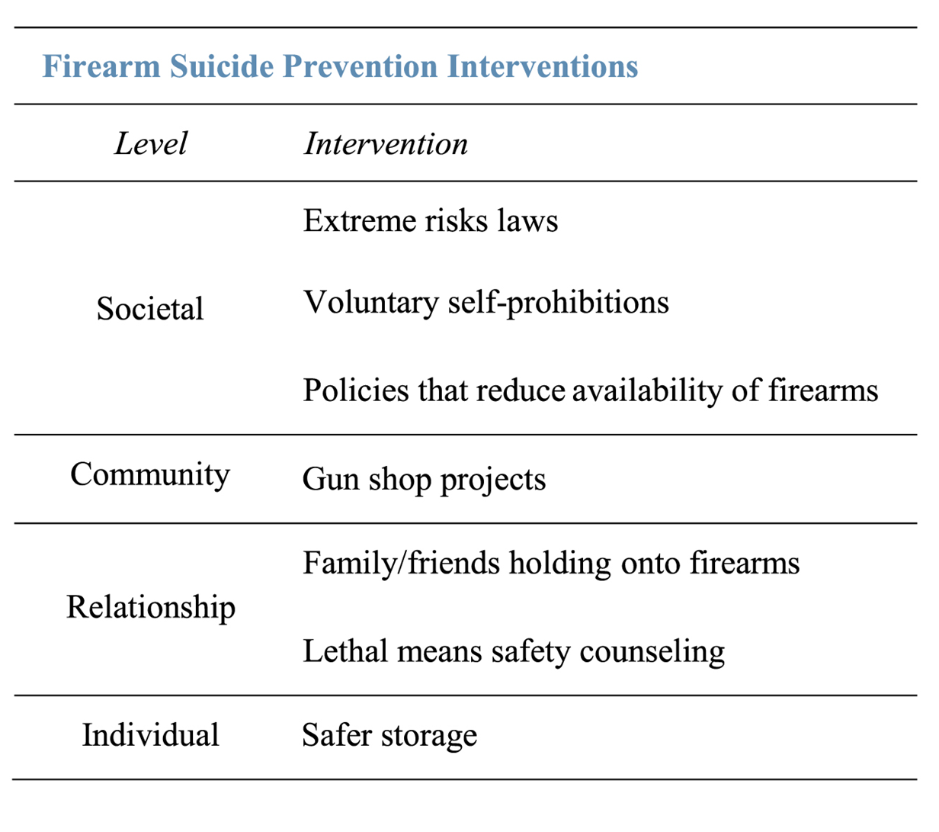
Source: Allchin A, Chaplin C, Horwitz J. (2018). Limiting access to lethal means: applying the social ecological model for firearm suicide prevention. Injury Prevention.

A Gun Violence Restraining Order (GVRO) is civil order that temporarily prohibits an individual who poses a significant danger of causing injury to self (including suicide) or others from purchasing or possessing any firearms or ammunition. The GVRO model is based on domestic violence protection orders. The GVRO enables law enforcement and families to proactively intervene and remove firearms from individuals who are suicidal or behaving dangerously. GVROs focus on behavioral risk factors, not mental illness, and the process is a civil rather than a criminal procedure. A GVRO creates safer circumstances for an individual to seek treatment, services, or otherwise access resources to address the underlying causes of their dangerous behaviors. The Orders are temporary and have built-in due process protections.

- The Speak for Safety campaign web site offers information and resources about GVROs in California.

The Education Fund to Stop Gun Violence recently launched the website Prevent Firearm Suicide (https://preventfirearmsuicide.efsgv.org/) to share information on best practices in firearm suicide prevention and also provide foundational research and evidenced based strategies around firearm suicide prevention.

The Gun Shop Project (GSP) is a collaborative effort to engage gun shop and firing range owners, their employees and their customers in preventing suicide. The GSP was originally developed in New Hampshire in partnership with the New Hampshire Firearm Safety Coalition. It has since been implemented in many states and counties around the nation, including several California counties.

The GSP shares educational materials with firearms retailers, firing range owners, and other key community partners about suicide prevention. Partners are asked to display a poster and brochure in their business and are offered information to help identify and address a customer that may be considering suicide.

- View and download EMM template materials that can be customized for local gun shop activities.

In addition to customizing gun shop materials based on work with local gun owners and gun shop employees, the County of San Diego is working with firearms safety instructors to implement suicide prevention content in firearm safety course, and created a web site “StopFirearmSuicideSD.org” to support the community in learning more about firearm safety and suicide prevention.

The American Foundation for Suicide Prevention has also launched a Firearms and Suicide Prevention Initiative that offers resources and materials to support local activities.

Counseling on Lethal Means

Lethal means safety counseling is the process that healthcare providers undertake to determine if an individual at risk for suicide has access to lethal means, and to work with the individual and their family or friends to reduce access until the risk of suicide decreases. Health care and other provider professionals are often unsure how to provide such counseling. Training and education about the effectiveness of means safety and how to have this conversation can increase the likelihood that providers will use this strategy when working with high risk patients/clients.

Lethal means safety counseling training should include information about the evidence-base for means safety strategies and to address common misconceptions. It should also include specific information about firearms, including legal information, to increase competency and comfort level in asking useful questions. The training should also review the best counseling techniques and offer tools for providers to use when patients have access to firearms.

- Counseling on Access to Lethal Means (CALM) is an online course designed by the Suicide Prevention Resource Center (SPRC) for professionals who work with people at risk for suicide. The course covers how to identify people who could benefit from lethal means counseling, ask about their access to lethal methods, and work with them, and their families, to reduce access.

Safety Planning

Safety planning is a collaborative effort between patient/client and treatment provider that is used to provide people who are experiencing suicidal ideation with a specific set of concrete strategies to use in order to decrease the risk of suicidal behavior. Including steps to reduce access to lethal means is an important part of safety planning.

Citation: Allchin A & Chaplin V, on behalf of the Consortium for Risk-Based Firearm Policy. (2017). “Breaking Through Barriers: The Emerging Role of Healthcare Provider Training Programs in Firearm Suicide Prevention.”

Safety planning resources
- Safety Planning: A quick guide for clinicians
- Patient Safety Plan Template
- Collaborative Safety Planning Presentation

Poisoning/Overdose

Safe disposal initiatives encourage individuals, providers, and pharmacies to work together to ensure that potentially dangerous medications that are no longer in use are properly disposed. Strategies include at-home disposal, where medications can be emptied into a container with water and an undesirable substance (e.g. kitty litter, coffee grounds), or disposal at a facility that accepts them.
- The Drug Enforcement Administration has on online search tool to find a safe disposal locations.

Another strategy is to work with pharmacies to disseminate medications in bags with information on crisis support and suicide prevention resources. Know the Signs developed a pharmacy bag design that was implemented through pharmacies in Glenn County. The bag included information about crisis resources and a message of hope.

In San Diego County, the suicide prevention council partnered with the school of pharmacy at University of California, San Diego to provide suicide prevention training for pharmacy students. A published report from the findings suggest that the training program helped the respondents build confidence in several self-efficacy areas relating to detection of suicide signs, response to patients with suicidal thoughts, reassurance for patients, and provision of resources and referrals.
Source: Painter NA, Kuo GM, Collins SP, Palomino YL, Lee KC. 2003. Pharmacist training in suicide prevention. J Am Pharm Assoc (2003). 2018 Mar - Apr;58(2):199-204.e2 (https://www.ncbi.nlm.nih.gov/pubmed/29366695)

Bridge Barriers

The effectiveness of installing physical barriers on bridges have been studied in several locations. Barriers can include fences or nets underneath the structure. A study that compared the effectiveness of a variety of different structural barriers found that installation of safety nets or fences led to a 71.7% reduction in suicides. Where "complete" barriers were installed (the entire length of the span was secured with no way to climb around barriers) there was an elimination of suicide deaths over the study period (1990-2013).

Source: Hemmer, A., P. Meier, and T. Reisch. 2017. Comparing different suicide prevention measures at bridges and buildings: Lessons learned from a national survey in Switzerland. PLoS One. 12(1): e0169625. https://www.ncbi.nlm.nih.gov/pmc/articles/PMC5218568/#pone.0169625.ref012

In California, a physical deterrent is under construction on the Golden Gate Bridge (https://www.goldengatebridgenet.org), and a process is underway to design a similar barrier for the Coronado Bridge in San Diego (https://www.coronadobridge.net).

Parking Structures

Parking structures often have open sides for ventilation, allow customers to enter with little or no security checkpoints, and generally have few people walking around. Parking garages near health centers are more frequently “hotspots” for suicide deaths than other parking structures. A survey from the International Parking & Mobility Institute found that 51% of parking organizations have experienced a suicide or an attempt at one or more of their structures.

There are several types of physical barriers that can be installed to support means safety in parking structures, from fencing or screening to landscaping, that deters easy access to heights.

Citation: Suicide in Parking Facilities: Prevention, Response, and Recovery. International Parking & Mobility Institute. https://www.parking-mobility.org/wp-content/uploads/2019/01/0416_IPMI-Suicide-in-Garages_2019_Final.pdf

Railways

Railway suicides account for less than 1 percent of all suicides in the United States; however the impact on rail suicides can be much higher in specific communities. Trespassing is the leading cause of rail-related fatalities in the United States, and a large proportion of trespasser fatalities are from suicides. While it is not reasonable to install fencing along an entire railroad line, it may be possible to target certain high-risk areas for fencing or other structural barriers that can reduce access or lethality of attempts.

Signage
Other strategies that do not involve physical barriers, such as signage, have been implemented in many locations. As of yet, there is little data to suggest that signage alone results in reductions in suicide incidents. One study did see reductions over a three-year period where a “hotspot” was used frequently for vehicle carbon monoxide suicides.

Placing signage that promotes crisis hotlines, intervention services, and/or sources of counseling in high-probability locations can encourage individuals with suicidal intent to call the hotline number. It is important to note that there are differing opinions among suicide-prevention experts about using signage on bridges and other high points. Some wonder if it may do more harm than good.

Where this strategy is used it is important to use wording that is safe and effective to the best of our current knowlesge. According to mental health experts, the use of the word “crisis” at the top, “hope” in the middle, and “fatal” at the bottom, is confusing for someone in crisis. It is also recommended to reduce the use of the word "suicide" in signage. Below is an example of a sign that provides a resource number to call, and includes enlarged type with a message of hope.
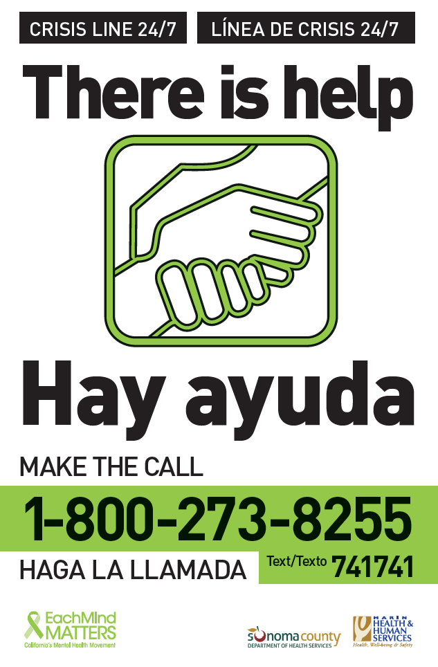
Citations
Countermeasures to Mitigate Intentional Deaths on Railroad Rights-of-Way: Lessons Learned and Next Steps. Federal Railroad Administration Technical Report; DOT/FRA/ORD-14/36. https://cms8.fra.dot.gov/sites/fra.dot.gov/files/fra_net/14240/Countermeasures%20Mitigate%20Deaths_20141124_final.pdf

King, E and N Frost. The New Forest Suicide Prevention Initiative (NFSPI). Crisis. 2005;26(1):25-33. https://www.ncbi.nlm.nih.gov/pubmed/15762081/”

Sample Goal and Objectives
Goal: Develop and implement tailored means safety strategies to reduce access to lethal means for those considering suicide
Objectives:
- Increase the number of health care professionals trained in counseling on lethal means, with focus on locations where individuals would receive care following a suicide attempt.
- Partner with the community and key stakeholders to expand existing efforts and strategies to reduce access to lethal means
- Implement county-wide firearm suicide prevention means safety campaign.
- Support existing projects to increase barriers and signage at sites and locations vulnerable to suicide attempts.
- Identify and collaborate with existing prescription drugs, opioid coalitions and programs to integrate suicide prevention and means safety.

Addressing Means Safety for Hanging/Suffocation

Like firearms, men are more likely to die by hanging/suffocation than females. Individuals younger than 30 years old are more likely to utilize this means. Means Safety measures around hanging and suffocation are difficult to implement because of the challenges with restricting access to means. Prevention and early intervention strategies such as identifying risk/suicidal ideation, connecting people to help, and developing a safety plan are still available.

Means Safety Resources

- Means Safety (Harvard School of Public Health): https://www.hsph.harvard.edu/means-matter/

- CALM: Counseling on Lethal Means (Suicide Prevention Resource Center): http://www.sprc.org/resources-programs/calm-counseling-access-lethal-means

- UC Davis, Firearm Injury Prevention Resources for Health Care Providers: https://health.ucdavis.edu/what-you-can-do/

- Breaking Through Barriers: The Emerging Role of Healthcare Provider Training Programs in Firearm Suicide Prevention: http://efsgv.org/wp-content/uploads/2017/09/Breaking-through-Barriers-September-2017-Consortium-for-Risk-Based-Firearm-Policy-FINAL.pdf

- Prevention Firearm Suicide (Education Fund to Stop Gun Violence): https://preventfirearmsuicide.efsgv.org/

- Firearms and Suicide Prevention (American Foundation for Suicide Prevention): https://afsp.org/about-suicide/firearms-and-suicide-prevention/

- Information about California's Gun Violence Restraining Order: https://speakforsafety.org

- Extreme Risk Protection Orders web site: https://americanhealth.jhu.edu/implementERPO

“Striving for Zero” California Strategic Plan for Suicide Prevention, Goals and Objectives
(https://mhsoac.ca.gov/what-we-do/projects/suicide-prevention/final-report)

STRATEGIC AIM 2: MINIMIZE RISK FOR SUICIDAL BEHAVIOR BY PROMOTING SAFE ENVIRONMENTS, RESILIENCY, AND CONNECTEDNESS
GOAL 4: CREATE SAFE ENVIRONMENTS BY REDUCING ACCESS TO LETHAL MEANS
- Desired Outcome Decrease in suicides and initial and subsequent intentional self-harm hospital visits.
- Short-term Target By 2025, all counties are using data and information to develop and implement targeted lethal means restriction strategies to prevent suicidal behavior and are measuring effectiveness.
State Objectives
- Objective 4a: Create a research and policy agenda to advance the goal of creating safe environments by reducing access to lethal means.
- Objective 4b: Monitor state-level trends in lethal means used for suicidal behavior and develop a statewide strategy for technical assistance to expand efforts to reduce access to the lethal means identified.
- Objective 4c: Disseminate information regarding federal funding available to support suicide barriers in the design or redesign of bridges and other sites where deaths by suicide may occur.
Local and Regional Objectives
- Objective 4d: Use the Public Health Model to evaluate risk and identify the methods of suicidal behavior used by community members and by specific demographic (such as race/ethnicity, age, sexual orientation, and gender identity) and cultural groups to guide development of focused prevention efforts. Once identified, develop tailored means restriction strategies and evaluate impact.
- Objective 4e: Promote safe medication disposal methods in the community or through pharmacies and other health care providers, including activities such as “take back” campaigns led by local public health departments that help people dispose of unused or expired medications. Partner with local pharmacies to increase the availability of methods to dispose of unused medication and highlight suicide and overdose prevention resources for people filling prescriptions.
- Objective 4f: Disseminate information to local gun shop and range owners to increase awareness of suicide prevention efforts, suicide warning signs, and available resources. Partner with local firearm safety trainers to incorporate suicide prevention awareness into trainings. Invite local gun shop and range owners to join local coalitions. Partner with law enforcement to guide dissemination of lawful options for temporarily transferring firearms for storage in times of suicide crisis or when Gun Violence Restraining Orders apply. Resources to support this strategy can be found here:
- Objective 4g: Disseminate information through local health departments to community partners about available overdose prevention resources, methods, and medications to counteract overdose, such as naloxone for opioid overdose.
- Objective 4h: Form regional and local workgroups composed of community members, first responders, transportation representatives, coroners and medical examiners, and crisis service providers to identify specific sites in the community frequently used for suicide, or those that provide the opportunity for suicide.
  - These sites can be in the built environment or natural sites. Common types of sites include buildings, bridges, and train railways. Characteristics communities should consider in identifying sites are places that provide the opportunity for a person at risk to fall from a height and sites from which falling would place a person in front of a moving vehicle, such as a train. More than one suicide at a site should raise safety concerns.
  - Once sites are identified, develop and implement plans to construct barriers to deter or prevent falling. Consider the benefits and risks of installing signs that list crisis services resources, such as suicide prevention hotline information, and provide positive, life-affirming messages. One risk, for example, could be drawing attention of people at risk to a particular site.
- Objective 4i: Create agreements among local bridge and rail authorities, first responders, and crisis services providers to collect data documenting events in which people were prevented from falling, any services they received and the outcomes. Include reporting requirements, such as biannual or quarterly reports.
STRATEGIC AIM 4: IMPROVE SUICIDE-RELATED SERVICES AND SUPPORTS
GOAL 11: ENSURE CONTINUITY OF CARE AND FOLLOW-UP AFTER SUICIDE-RELATED SERVICES
- Desired Outcome Reduce subsequent suicidal behavior among people discharged from emergency departments and hospital settings after suicide-related services.
- Short-term Target By 2025, all people prior to being discharged from emergency departments and hospital settings after receiving suicide-related services create a plan for follow-up care and contact over a 12-month period or more, as needed.
State Objectives
- Objective 11a Create a research and policy agenda to advance the goal of ensuring continuity of care and follow-up after suicide-related services.
- Objective 11b Establish a program to deliver training on lethal means restriction counseling to health care providers, and distribute gun and medication lock boxes and locks to hospitals, with prioritized distribution to families and caregivers of people being discharged following a suicide attempt.
- Objective 11c Ensure delivery of best practices for continuity of care following discharge after suicide related services in emergency departments and hospital settings, including the routine, standardized use of follow-up cards, texts, and emails.
Local and Regional Objectives
- Objective 11d Increase the use of electronic health records to document a person’s safe transition to another provider, and ensure life-saving information is transmitted, while protecting the person’s privacy.
- Objective 11e Facilitate safe and timely care transitions by providing linkages to culturally and linguistically appropriate outpatient behavioral health providers, crisis services, safety planning or crisis response planning, and by reducing access to lethal means.
- Objective 11f Disseminate to emergency department administrators the Caring for Adult Patients with Suicide Risk: A Consensus Guide for Emergency Departments found at http://www.sprc.org/sites/default/ files/EDGuide_full.pdf, along with the Quick Guide for Clinicians found at http://www.sprc.org/sites/default/ files/EDGuide_quickversion.pdf, to increase awareness of safe discharge practices for people seen for suicide-related services.
- Objective 11g Train health care providers to deliver lethal means counseling to family members and caregivers supporting people who are discharged from a health care setting after suicidal behavior.
- Objective 11h Disseminate information on lethal means counseling to health care providers across hospital settings. Prioritize providers who predominantly serve at risk-groups or work in high-risk settings, such as emergency departments. Promote free online training, such as Counseling on Access to Lethal Means available at https://training.sprc.org/, and the use of online toolkits, such as https://health.ucdavis.edu/what-you-can-do/.
- Objective 11i Create uniform policies and procedures for safely transitioning people or students back into the workforce and home or school following a suicide attempt, suicide, or hospitalization for a behavioral health crisis.
- Objective 11j Create uniform policies and procedures to connect people released from correctional settings who have been identified as at risk for suicide, or who were receiving suicide-related services in custody, to appropriate services in the community. Include a standardized process for transferring confidential data and information.
- Objective 11k Create uniform policies and protocols to support health and behavioral health care providers in the creation or revision of safety plans for persons at risk. Examples include uniform procedures for establishing a connection between the person and a new provider; policies ensuring timely delivery of information to the new provider; and policies addressing the importance of follow-up within 24 to 48 hours of the transition. Create memorandums of understanding among local crisis service providers to establish relationships with people prior to discharge and ensure follow-up after discharge.
- Objective 11l Create uniform protocols for counseling people discharged from emergency departments and hospitals after receiving suicide-related services on restricting access to lethal means. Families and caregivers should be included in such counseling.

