Talking Points and Data Briefing on Suicide Prevention in the Workplace

Take-Home Points
- Approximately 70% of suicide are among working age adults.
- Most adults spend the majority of their day at work, so the workplace is one of the best settings to reach them.
- Many working age adults are balancing time at work with life obligations; this fact and job-related stress and satisfaction with work can negatively impact mental health.
- Certain occupations have higher rates of suicide than others; despite their reputation for potentially dangerous work conditions, suicide rates in these occupations exceed fatalities due to work related injuries.
- These occupations are characterized by several risk factors for suicide, include being predominantly male, access to lethal means, and high stress and high-pressure work environments.
- Promoting mental wellness is good business; supportive and healthy work settings are both more productive and can save businesses substantial costs by preventing illness and disability.
- Comprehensive strategies for workplace suicide prevention are based on effective, evidence-based programs that have been shown to reduce rates of suicide as well as other deleterious outcomes.

Why Focus on Suicide Prevention in the Workplace?
Approximately 70% of suicides are among working age adults between the ages of 18-64. Whereas historically rates of suicide (which control for population size and provide a measure of impact on a particular group) have increased with age, in the last 10 years the rates of suicide are increasing most rapidly among working age adults.

Most adults spend a significant portion of their lives at work. According to the U.S. Bureau of Labor Statistics, working and related activities account for the majority of the day. This is more time than they spend doing all other activities combined, including leisure and taking meals, except for sleeping.

For many adults, time spent at work is balanced, often precariously, against the need to care for children and aging parents. A Pew Research Center study reported that that nearly half of adults in their 40s and 50s are both raising or supporting a child, while providing some emotional and even financial support for aging parents. The study also found that their strong sense of responsibility to both generations can lead to increased emotional, time, and financial stress.

The sandwich generation pours their energy and hours into the need to earn a living and care for dependents, with very little time left to attend to their own needs. Their identity is often tied closely to their employment and their role as caregivers and providers. When financial hardship hits such as job loss and debt, they may feel exponential distress over a perceived failure to take care of those that depend on them.

Issues related to job satisfaction and work/family balance can play a major role in suicide risk among working age adults. A recent study published in the Journal of Psychology found that the characteristics of a job and how their work is perceived are directly associated with depression and suicidal ideation, and indirectly with risk of suicide attempts. The study’s authors suggested that supportive workplace policies that enhance job satisfaction and connect vulnerable employees with help are vital to a comprehensive approach to suicide prevention in our communities.

Suicide prevention strategies that seek to reach working age adults have a significant challenge.
Whether employed or not, they are dispersed throughout communities. They do not gather daily in one setting, like high school students. Places of employment can be very large, with thousands of employees, or very small mom and pops. Those who work at locations that are part of national corporate chains operate under an umbrella of policies and procedures that can be hard to influence from the outside. Employment can be seasonal, intermittent, or at will, leading to frequent change in where people go to work and what hours of the day they are at work. Some occupations are solo ventures and people work in isolation.

Despite the challenges, the call to action is clear.

Suicide and Occupation
A recent Centers for Disease Control and Prevention analysis of data from the National Violent Death Reporting System reported that compared with the general population, suicide rates are significantly higher in five major industry groups: 1) Mining, Quarrying, and Oil and Gas Extraction; 2) Construction; 3) Other Services (e.g., automotive repair); 4) Agriculture, Forestry, Fishing, and Hunting; and 5) Transportation and Warehousing. The report also found significantly higher among the additional occupational groups of Installation, Maintenance, and Repair; Arts, Design, Entertainment, Sports, and Media; 4) Transportation and Material Moving. For most of these occupations, elevated rates were found primarily for males. However, elevated rates for females were found within Protective Services and Healthcare Support.

Although these job categories cover a lot of ground, many share several characteristics, including job-related isolation and demands; stressful work environments; potential for work-home imbalance; socioeconomic inequities including lower income, lower education level, and potential for financial losses; barriers to and unwillingness to seek mental health services (which might be limited in rural areas); and access to lethal means.

One study based on national surveys found that occupation has a significant relation to self-reported suicidal ideation (Han et. al 2016). Higher levels of self-reported suicidal ideation occurred among occupations such as lawyers, judges, and legal support workers, social scientists and related workers, and media and communication workers, than in the industries with higher documented rates of suicide deaths (farming, forestry, construction). The authors suggested several explanations for this, an important one being ready access to highly lethal means.

Negative perceptions of the workplace, particularly around job autonomy, work-family conflict, and overall job dissatisfaction are linked to depression and risk of suicide ideation and attempts (Howard & Krannitz, 2017). Creating policies and management practices that enhance employees’ positive perceptions of their job may help to reduce negative perceptions and releve some of the stress around work and family life, such as offering flexible work schedules, telecommuting options, and more autonomy and variety of tasks.

Construction

The construction industry is characterized by several factors that can increase risk for those working in the field. The Construction Industry Blueprint for Suicide Prevention) identifies the following risk and protective factors for construction workers and managers:
- Access to lethal means (such as firearms, pills, high places such as bridges or buildings, heavy equipment)
- Capability for fearlessness (culture of recklessness, bravery, stoicism, reward for being tough)
- Exposure to physical strain or psychological trauma (exposure to life threatening situations and events, chronic pain, burnout)
- Culture of substance abuse (informal support for self-medication and overuse of substances to work through fatigue or pain, and to let off steam)
- Fragmented community/isolation (transitory or seasonal work, less sense of community and belonging, frayed social networks)
- Humiliation/Shame (problems with work lead to sense of failure, affecting identity)
- Entrapment (feeling that things must be done that they wouldn't normally do, no other way to meet their goals but to go along)
- Nature of the work (cyclical lay-offs and re-hiring, uncertainly about employment, economic stress, “pressure cooker” atmosphere)

Protective Factors:
- Culture promoting the importance of safety
- Emphasis on teamwork
- Culture of employee engagement and connectedness, “brotherhood”
- Culture of wellness that values mental health
- Access to insurance and mental health care
- Informational support systems (buddy systems)
- Leadership and supervisor training

Initiatives under way within the industry to better equip field managers and industry leaders to communicate supportive and helpful information that acknowledges challenges and encourages people to reach out for help.

The construction industry has made a commitment to addressing the issue of suicide. Working with the Carson J Spencer Foundation and the Action Alliance for Suicide Prevention, the industry developed the Construction Industry Blueprint for Workplace Suicide Prevention. This document reviews risk factors in detail and offers tools for workplaces to self-assess and take concrete steps to reduce risk factors and promote protective factors.

The Construction Industry Alliance for Suicide Prevention is dedicated to raising awareness about suicide and sharing resources and tools for contractors, unions, trade associations, industry service providers and project owners to work together for suicide prevention. Reach out to the Alliance to find out more about partnering with construction companies, associations, and their colleagues in your community.

Farming

A number of environmental influences may contribute to the increased risk of suicide among farmers, including: extreme climatic events; isolation; service availability; access to, and frequent use of firearms; death and suffering of animals; government and legislation; technology; and property values. Both the physical and socio-cultural environments in which farmers operate appear to contribute to farmer suicide and need to be considered in suicide prevention.

Recent research has found that as a group, farmers have higher rates of depression, anxiety, and suicide risk than the general population. Farmers often feel called to the vital work of feeding others, and it is common for families to continue farming over multiple generations; the work is “in their blood". These and other factors can foster a determination to continue even as things get difficult, and a sense of personal and familiar failure when things do not work out. It can be difficult to reach out for help, not in the least because many farmers work in isolation and in rural areas where access to services and supports are often more limited than in urban areas.

Several organizations and initiatives have formed to support farmers and work to address challenges and reduce the need to struggle through them in isolation. Working with local agricultural associations, distribution networks, and organizations such as community granges to offer support and linkage to crisis, mental health, and financial assistance resources are ways to reach farmers where they are with hope and support and lend your behavioral health expertise to existing and trusted . These messages and resources should also be communicated to communities and helpers, such as families, who can help assess risk and encourage help seeking.

SFarm Crisis Center
- Farm Aid hotline (800-FARM-AID/800-327-6243), Monday-Friday from 9a.m.-5p.m. ET.
- Farmer Resource Network online directory of local resources around a variety of issues
- Rural Health Information Hub, Rural Response to Farmer Mental Health and Suicide Prevention Resources
- Agriculture & Natural Resource Center of Excellence, based in Washington

Workplace Suicide Prevention Strategies
Promoting mental wellness is good business. Employees are the greatest asset in any business, large or small. Untreated and unsupported mental health challenges cost businesses in lost productivity, missed work, disability and worker’s compensation. The human toll, in suffering and distress, is even more important.
Working Minds estimates that more days of work loss and work impairment are caused by mental illness than many other chronic conditions such as diabetes, asthma and arthritis. In a three-month period, patients with depression miss an average of 4.8 workdays and suffer 11.5 days of reduced productivity, and Depression is estimated to cause 400 million lost workdays each year at a cost to employers of $17 to $44 billion.
General Strategies for Workplace Suicide Prevention

- Promote resources such as the Suicide Prevention Lifeline and Employee Assistance Programs, where available.
- Provide training to all employees in recognizing warning signs and how to respond.
- Participate in mental health screening days and other wellness-oriented events.
- Wherever possible, offer policies and management practices that enhance job satisfaction and reduce work-family conflict.

Tools and resources to implement these steps can be found in the Suicide Prevention Week 2018 Toolkit – Focus on the Workplace Resource Guide, and the National Action Alliance for Suicide Prevention’s web site Comprehensive Blueprint for Workplace Suicide Prevention.

Strategies outlined in the blueprint include upstream (prevent problems from happening in the first place), midstream (identify problems early and connect people to help), and downstream (safe and compassionate responses to mental health crises)

Information shared includes:
- Awareness of the magnitude of the problem and a call to action to save lives
- Warning signs of suicide
- Practicing a conversation with someone you are concerned about: Notice, ask listen, support, and follow-up

Table ##: Comprehensive blueprint for suicide prevention in the workplace

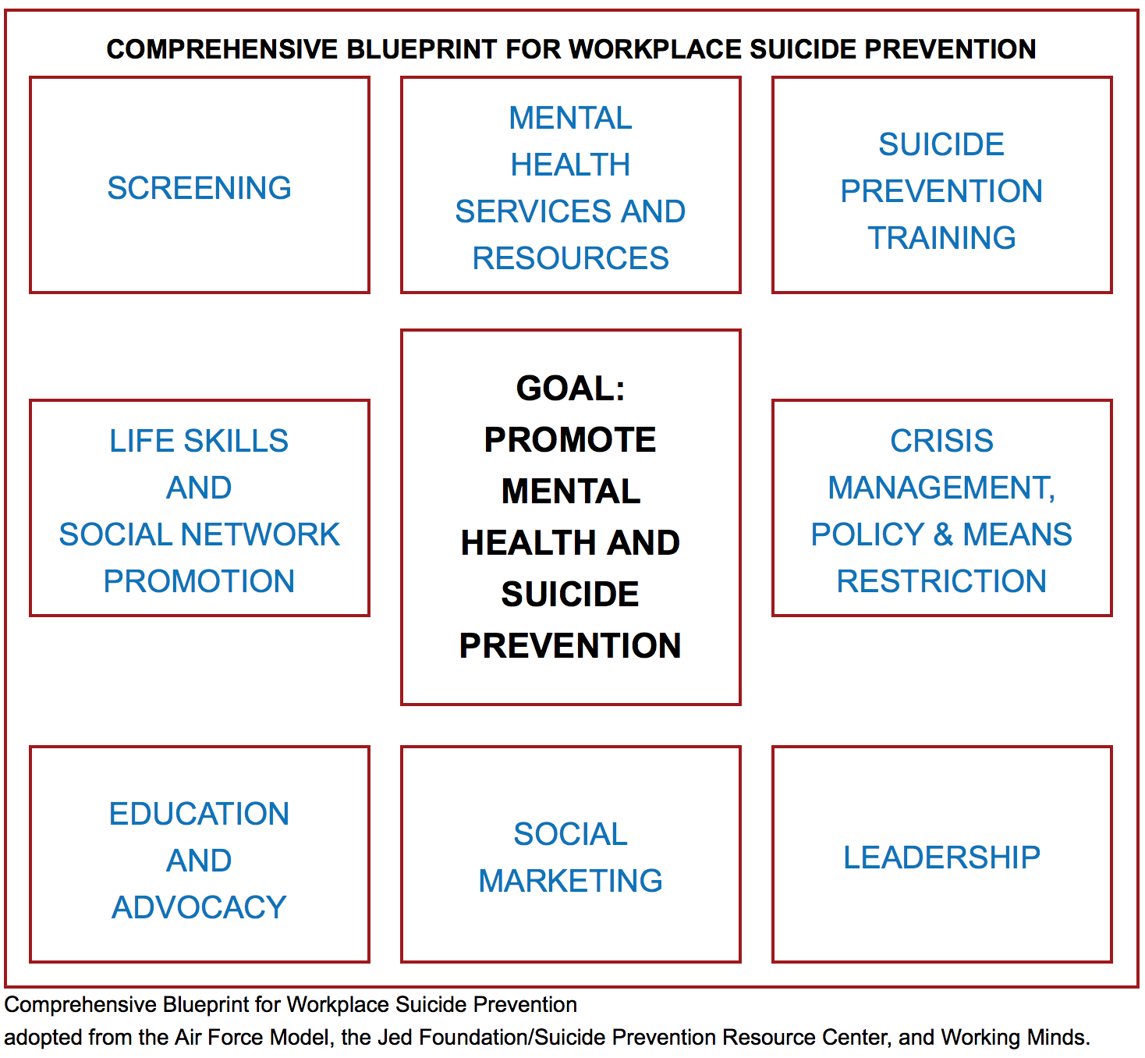

Are you ready? Do an assessment. Ask the following questions of your work place:
- What is the sense of urgency?
- How does the price of not doing suicide prevention compare to the price of implementing suicide prevention?
- Do major stakeholders support suicide prevention (within and external to the organization)?
- How does leadership within the organization view suicide prevention?
- How will suicide prevention align with intended organizational core values and goals?
- How will planning and implementation for suicide prevention be supported and sustained?

If your organization has both high leadership support and high organizational support, then you are ready for change. If you lack one of these elements, you may be ready for learning, but will need to get more buy-in before successful change can happen. Start with the areas where you have both high levels of leadership and organizational support.

Breaking Down the Blue Print

Screening http://actionallianceforsuicideprevention.org/task-force/workplace/cspp/screening

- Hold Mental Health Screening Days
- Promote online screening tools and encourage their use

Mental Health Services and Resources
http://actionallianceforsuicideprevention.org/comprehensive-blueprint-workplace-suicide-prevention-1
- Create an inventory of behavioral health resources that are available to employees, through work and in the community. Make the inventory available to employees. Encourage their use by working to reduce the stigma around mental health.
- Promote use of employer-offered health insurance policies; otherwise become familiar with mental health coverage in health insurance packages, what services are available for uninsured or underinsured
- Work with EAP to promote counseling and behavioral health services and make them friendly, easy to find and use

Suicide Prevention Training
Offer training for all staff. Work with managers to ensure they know how to support their staff and what to do if someone approaches them with concerns about themselves or another employee.

The following are recommended training modules. There are costs associated with training, but it is worth checking with these organizations to see if there are trainers in your area that may be able to offer the training and reduced or no cost. Contact your local behavioral health agency to ask about training. Crisis Centers are another potential resource for training. Some of the organizations below offer training online.
- Working Minds offers a 2-hour training module on workplace suicide prevention as well as an 8-hour train the trainer at a modest cost. More information about the training is available on the Working Minds web site https://www.coloradodepressioncenter.org/workingminds/
- QPR: www.qprinstitute.com
- ASIST and Suicide Talk: LivingWorks: www.livingworks.net

Life Skills and Social Network Promotion
- Promote a culture of community, where employees are supportive of one another and management and staff of one another as well. Consider use of a “buddy system”.
- Offer resources for help with financial, legal, and personal challenges.
- Offer opportunities to build community – fun events, wellness events, etc.

Crisis Management, Policy & Means Restriction
- Establish a protocol for managing a crisis in the work place. This can include on-site events but also a crisis off-site directly involving or impacting employee(s). The protocol includes strategies for crisis intervention, connection to crisis resources, reducing access to lethal means, communication, and support for others affected by the crisis.
- http://actionallianceforsuicideprevention.org/task-force/workplace/cspp/crisis

- Consider offering information about the free online course, counseling on access to lethal means, particularly if your workplace includes potentially lethal means.

- Postvention – have a plan for communicating information with employees after a suicide death, connection to support for those affected, communication of crisis and mental health resources
  - Manager’s Guide to Postvention in the Workplace: http://actionallianceforsuicideprevention.org/task-force/workplace/cspp/crisis

Education and Advocacy and Social Marketing
- Create a culture of openness to discussing mental health concerns. Posters, brochures and other outreach materials from Know the Signs, Each Mind Matters, the Suicide Prevention Lifeline, etc. are all good materials to have readily available around your workplace, in break rooms, etc. Seeing these materials communicates the message that there is help, and also that your workplace supports people seeking help.

- Have brown bag presentations, wellness fairs, social media posts, or articles in company newsletters that share information from and about advocacy groups such as the American Foundation for Suicide Prevention (a local or regional chapter might be willing to offer a presentation, co-host an event, or share materials with you). Other excellent advocacy groups can be found in this document: http://actionallianceforsuicideprevention.org/task-force/workplace/cspp/education

Social Marketing
- Take education to the next level with social marketing strategies that seek to change the conversation – how people think and behave – about mental health. Social marketing uses consistent messaging strategies and engages people in taking real action for change. This link includes several web sites and tool kits that can be useful. http://actionallianceforsuicideprevention.org/task-force/workplace/cspp/marketing

- The Each Mind Matters Social Media Guide and Know the Signs How to Use Social Media Guide for more ideas and tools. This toolkit also contains several social media strategies for use in Suicide Prevention Week and beyond.

- Visit the Each Mind Matters Resource Center to see the full catalog of mental health and suicide prevention resources available to you.

Leadership
- Leadership can come from many places – from CEOs to natural leaders that have a lot of influence among their peers. Who are the leaders in your organization? Whoever they are, there are many examples of how committed leadership can model and inspire real change. This web site offers some examples and some stories from leaders in various fields: http://actionallianceforsuicideprevention.org/task-force/workplace/cspp/leadership

- The Sources of Strength program offers another example of cultivating peer leaders to use their social influence to effect real change within schools and communities. Although not a workplace-specific strategy, this powerful approach has many lessons to offer any setting.

Workplace policies and management strategies
- Where possible, create a balanced work environment where employees have some autonomy over their work, and a variety of projects are available.
- Flex time and telecommuting may be helpful when employees have a lot of demands at home or a long commute. An example is offering the opportunity to choose work hours that create less conflict with getting children to and from school or making up hours needed to get an ailing relative to doctor’s appointments, without losing paid hours.
- Where these strategies are not feasible, or in addition to these strategies, offer training and education on signs of depression and effective coping strategies. Interpersonal education and training that promote respect and civility among staff and between staff and managers. Wellness oriented events and activities such as these can break up the day and send the message that the whole employee is valued.

Addressing Access to Lethal Means

The Know the Signs Suicide Prevention Week 2017 toolkit offers strategies and resources to reduce access to lethal means for those who are in a crisis.

Means reduction strategies can take several forms, beginning with knowing how to assess risk and talk to a someone about concerns, to implementing informal or legal arrangements that promote safety by temporarily separating the person from highly lethal means. The majority of the resources focus on firearms because firearms remain the most frequent mechanism by which people end their lives.

Counseling on Access to Lethal Means is a 1.5 hour online training that educates health care providers and others about assessing risk and suggesting strategies.

The Gun Shop Project is a partnership that provides materials and support for firearms retailers and firing range owners to recognize and respond to potential suicide risk among clients. See materials customized for use in California here.

California’s Gun Violence Restraining Order (GVRO) is a law that allows family or household members and law enforcement officers to obtain a court order that temporarily prohibits an at-risk person from accessing guns or ammunition, and temporarily prohibits that person from purchasing or obtaining any new guns and/or ammunition. The GVRO is a civil, not a criminal procedure. The goal is to ensure safety and allow the opportunity to heal and stabilize. However, if the order is violated, the subject would then be guilty of a misdemeanor crime. When the order expires, firearms and ammunition may be returned to the restrained person.
If you think there is a strong likelihood that a family member, roommate, or household member would harm themselves or others, petitioning for a GVRO can be an important first step to reduce the risk of harm. Visit https://speakforsafety.org to learn more.

The following are firearm-specific strategies that can be used to keep someone safe:
- Ensure that all guns are securely locked using trigger locking mechanisms and/or locking ammunition away from the firearm
- Make guns less lethal, for example store them unloaded, replace live ammunition with blanks, and disable trigger mechanisms
- Remove guns from the home and temporarily store them with a friend or family member
  - In some states, family members or friends can temporarily store guns at their own house without the background checks otherwise associated with firearm transfers.
  - In California, guns can be transferred between family members without the involvement of a licensed dealer, with the exception of siblings. See more information about California gun laws here.
  - Other storage sites might include gun shops or ranges, pawn shops, and law enforcement agencies.
- Unwanted firearms can be disposed of permanently by selling them or giving them away (in both cases, the recipient must be legally allowed to possess a firearm) or surrendering them to law enforcement. These options vary by location and may require background checks or other paperwork.

Lethal means can also include high places and heavy equipment in some occupational settings. The Occupation Safety and Health Administration’s web site includes guidelines for workplace safety intended to prevent accidental injury, but can also be used to create policies and procedures in the workplace that can reduce the ready availability of lethal means. Include a plan to heighten safety in the workplace whenever an individual shows signs of distress or may be in crisis.

- Agricultural occupations: https://www.osha.gov/dsg/topics/agriculturaloperations/hazards_controls.html

- Construction industry: https://www.osha.gov/doc/

Construction Industry Suicide Prevention Initiatives

Citations

National Public Radio, Inc. “As Milk Prices Decline, Worries About Dairy Farmer Suicides Rise”. (Aired on All Things Considered, Feb 27, 2018)

Matt Howard & Morgan Krannitz (2017) A Reanalysis of Occupation and Suicide: Negative Perceptions of the Workplace Linked to Suicide Attempts, The Journal of Psychology, 151:8, 767-788, DOI: 10.1080/00223980.2017.1393378 (https://doi.org/10.1080/00223980.2017.1393378)

2016 American Time Use Survey. U.S. Bureau of Labor Statistics. https://www.bls.gov/
https://www.bls.gov/news.release/archives/atus_06272017.pdf

McIntosh WL, Spies E, Stone DM, Lokey CN, Trudeau AT, Bartholow B. Suicide Rates by Occupational Group — 17 States, 2012. Morbidity and Mortality Weekly Report, 2016;65:641–645. DOI: https://www.cdc.gov/mmwr/volumes/65/wr/mm6525a1.htm

Carson J Spencer Foundation & National Action Alliance for Suicide Prevention (2015). A Construction Industry Blueprint: Suicide Prevention in the Workplace. Denver, CO: Carson J Spencer Foundation. http://www.constructionworkingminds.org/assets/constructionguide.pdf
Assessing Suicide Risk for Farmers. Successful Farming, agriculture.com
https://www.agriculture.com/family/health-safety/assessing-suicide-risks-in-farmers

Farmers and Suicide: Help is Available
https://www.farmaid.org/blog/farmers-and-suicide-help-is-available/

Han B, Crosby AE, Ortega, LAG, Parks SE, Compton WM, Gfroerer J. Suicidal ideation, suicide attempt, and occupations among employed adults aged 18–64 years in the United States. Comprehensive Psychiatry. 2016; 66: 176–186. (https://www.ncbi.nlm.nih.gov/pmc/articles/PMC4959536/)

Hoffmire CA, Kemp JE, Bossarte RM. Changes in Suicide Mortality for Veterans and Nonveterans by Gender and History of VHA Service Use, 2000–2010. Psychiatric Services. 66:9, September 2015 (https://ps.psychiatryonline.org/doi/pdf/10.1176/appi.ps.201400031)
Matt Howard & Morgan Krannitz (2017) A Reanalysis of Occupation and Suicide: Negative Perceptions of the Workplace Linked to Suicide Attempts, The Journal of Psychology, 151:8, 767-788, DOI: 10.1080/00223980.2017.1393378. https://doi.org/10.1080/00223980.2017.1393378

The National Action Alliance for Suicide Prevention Responds to CDC Article. http://actionallianceforsuicideprevention.org/sites/actionallianceforsuicideprevention.org/files/CDCResponse.pdf

U.S. Bureau of Labor Statistics. Fatal occupational injuries counts and rates for selected occupations, 2015-2016. Retrieved from: https://data.bls.gov/cgi-bin/print.pl/news.release/cfoi.t03.htm

Pew Research Center Social & Demographic Trends. The Sandwich Generation: Rising financial burdens for middle-aged Americans. Jan. 30, 2013, retrieved from
http://assets.pewresearch.org/wp-content/uploads/sites/3/2013/01/Sandwich_Generation_Report_FINAL_1-29.pdf

http://www.pewsocialtrends.org/2013/01/30/the-sandwich-generation/

Han et. al., 2016. https://www.ncbi.nlm.nih.gov/pmc/articles/PMC4959536/
Peterson C, Sussell A, Li J, Schumacher PK, Yeoman K, Stone DM. Suicide Rates by Industry and Occupation — National Violent Death Reporting System, 32 States, 2016. MMWR Morb Mortal Wkly Rep 2020;69:57–62; DOI: http://dx.doi.org/10.15585/mmwr.mm6903a1external icon
Perceval M, Kõlves K, Ross V, Reddy P, De Leo D. Environmental factors and suicide in Australian farmers: A qualitative study. Arch Environ Occup Health. 2019;74(5):279-286. doi: 10.1080/19338244.2018.1453774. Epub 2018 May 3. PMID: 29558258.
Bjornestad,A.; Cuthbertson, C.; Hendricks, J. An Analysis of Suicide Risk Factors among Farmers in the Midwestern United States. Int. J. Environ. Res. PublicHealth2021,18,3563. https:// doi.org/10.3390/ijerph18073563
National Public Radio, Inc. “As Milk Prices Decline, Worries About Dairy Farmer Suicides Rise”. (Aired on All Things Considered, Feb 27, 2018)

